Forest Methodist Church

March Newsletter

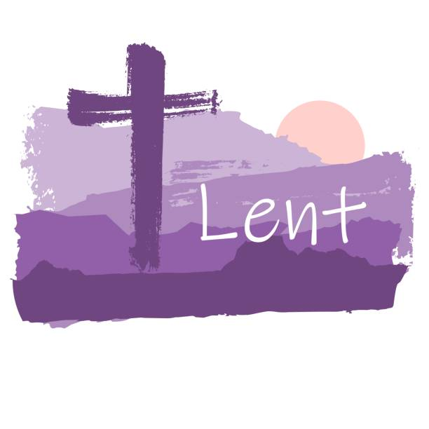

Serve Learn Share Praise
Methodist Church 
Bailiwick of Guernsey
Minister:
Rev’d Jacky Cottrell
The Manse, 2, Le Chene D’Mont, Le Chene,
Forest, GY8 0AL Tel: 234105
Email: revdcottrell@gmail.com

Hello friends,
For some time, I have looked out of the window and witnessed Spring: bright yellow Narcissus, in the front way, colourful pink Camellia out the back, glimpses of sunny rays, and fields of dancing daffodils. But once outside the chill has reminded me, quite rapidly, we are not there yet and appearances can be deceiving.
Coming from north of England the springing of plant life does come later. The days are however now lengthening, so Spring is just around the corner. This year meteorologically it will be March first to May thirty-first. The astronomical spring equinox begins March twentieth.
Just as Spring is confusing me, the deceiver tries to confuse and catch us all out. The deceiver had Eve convinced no harm would come from picking the fruit, his coaxing did not work on Jesus in the wilderness. The world will try to use many ways to deceive us and we have to be aware. There is a story of a minister’s wife who kept buying dresses, he said to her she had plenty and must not buy anymore. She whined it was hard to resist, so he gave the advice to say ‘Get thee behind me’ at her next temptation. The next evening there was another bag, containing another dress.
He was disappointed, ‘What happened to my advice?’ he asked her. ‘Well’ she said, I did say it to him and he said, ‘It looks lovely from the back too!’
The biggest deceiving is what we give ourselves. In this time of Lent, spend time to be very truthful with yourself and with Jesus’ gentle guidance we can grow stronger in our faith. Let it spring up and blossom to others around you.
Big blessings, Revd Jacky




Soup Lunch

At Forest Methodist Church
Saturday 14th March – 12 - 2pm
Cost: £6
All proceeds to our two chosen charities:
Shelter Box and Our Only World

Lent
We have opportunities to study together for one hour in Lent. Tuesdays 7.30p.m. Each stands alone so please attend any you can.
Knowing this might be difficult for some of you here is some study you can do at home. If you go to https://uk.langham.org/get-involved/free-lent-study-guide/ you can see all the resource book and videos to watch. It uses the fruit of the Spirit to guide us to becoming like Jesus.
For a technology free version, grab your bibles. Perhaps gather some friends to share. Opening prayer each week… Lord help me to grow closer to you through the words of the bible and guide me to live more like you. Amen.
Week 1
First think or discuss the saying ‘Do as I say not as I do’.
- Have you ever been on the wrong end of this attitude?
- Have you been tempted to use this yourself? Now read Matthew 14:13-2. Jesus’ compassion to the crowds
- Think about the economic situation of Jesus’ time.
- Why did Jesus go to a solitary place? What does this teach us about Jesus’ humility?
- Contrast the disciples attitude to Jesus’. Now read John 6:5-15
- What differences do you notice?
- Contrast the boys attitude to that of the disciples.
- Think about/discuss the principles Jesus demonstrates in the receiving and distributing of the bread.
- What does these 2 passages tells us of the character of Jesus?
- How can you individually apply Jesus’ example to your life?
Week 2 Saying - ‘Religion poisons everything’
- How do you react to this view of society? Now read Matthew 26:6-16 - Jesus is anointed
- What significance is there in the description of the homeowner as Simon the Leper? How does this reflect on Jesus?
- Why do you think the women chooses to pour expensive oil on Jesus’ head? Contrast the disciples’ reaction to that of Jesus.
- How would you answer the disciples’ comment that the poor would have benefited more?
- Has our church ever had to debate use of resources for enhancing church or providing for needs of others? How was it resolved?
- Judas betrays for personal gain, how do we ensure money does not became centre of worship?
- What aspect of the life of Jesus in this story would you want to emulate?
Week 3 Saying - ‘I don't believe in barcode Christian.’
- What do you think this saying means? Do people see Christians as all the same? Does being like Jesus mean we are the same? Now read Matthew 14:22-36. - Faith in Jesus
- Look further back to 14:1-21 and see the context of this story. If you were Jesus, how would you feel at this time?
- What priority does Jesus give to pray, with regards to his time and setting for his prayers?
- What can we learn from Jesus’ prayer life?
- Why do you think he chose to walk across the water at 3 o’clock?
- What purpose does Jesus have in telling Peter to come to him?
- What part does faith and doubt play in this story?

- Jesus performs two miracles, how can we let this revelation enhance our worship?
- Compare verse 14 and 36, what does this teach us of Jesus’ attitude to the sick?
- Is there any part of this example of how Jesus lived that you want to pray to God to help you with?
Week 4. Saying - ‘No nation is better than is sacred book.’
- Do you agree with this statement? What book defines our nation? Read Matthew 4;1-11 - Jesus and Satan
- What has happened immediately prior to this story?
- Why did the Spirit lead Jesus from an amazing blessing to this time of trial?
- Have you ever experienced a blessing immediately followed by difficulties? What did you learn from this experience.
- Jesus chose to fast 40 days and nights. Does this example set a model for Christians to folllow?
- Should the church encourage this, should there be some safeguards?
- What aspect of fasting do you think are useful for Christians?
- How does Jesus answer Satan’s temptations?
- How may the bible be misused?
- Does Jesus knowledge of his Hebrew bible, encourage you to have a better understanding of your bible?
- Jesus’ answer to the third temptation - does this help you in your dealing with temptation.
- What aspect of Jesus’ life speaks to you most from this passage?

MEET & EAT
Meet & Eat will be held here at Church,
tomorrow Monday 2nd March at 7pm
and will be led by Helen Mahoney.
For catering purposes, please add your name to the sheet in the Welcome Area.
Also, please note, the minimum contribution is now £6. This is the first increase ever.
.

FOREST LADIES GROUP.
Ladies come and join us on
Thursday 12th March at 2.00pm
Musicals. - Victor Lane
Thursday 26th March at 2.00pm
Easter Celebrations
WARM WELCOME TO ALL LADIES
Further details from Beth
Tel: -7781 163564
Warm welcome to all Ladies
Further details from Beth
Tel: 07781 163564

Preaching & Duty Stewart Schedule
God & Marmalade is at 8.45am
Date | AM Preacher | Duty Steward
1st March | Fellowship | Sarah
8th March | Fellowship | Rosemary
15th March Mothering Sunday | Jacky Cottrell (HC) | Carole
22nd March | Victor Lane | Nev
29th March Palm Sunday | Jacky Cottrell | Sarah
2nd April  Maundy Thursday | Jacky Cottrell | N/A
3rd April  Good Friday | 11am Jacky Cottrell | Beth
5th April Easter Day | Jacky Cottrell | Carole

There are no Evening Services during March. Services restart on Easter Sunday April 5th

Flower Rota
Date
1st March | Sandra in memory of Maggie
8th March | Debbie Dorey
15th March | Michelle Gilson
22nd March | Sarah Plumley
29th March | Jenny Falla
5th April | Jenny Falla

Welcome Steward Rota
DATE | AM | PM
1st March | Andrea
8th March | Brian
15th March Mothering Sunday | Debbie A
22nd March | Andrea
29th March Palm Sunday | Michèle
5th April Easter Day | Sandra | Brian

G & M Breakfast Rota
Date | Breakfast | Setting Up | Cloth Wash
1st March | Debbie D/Rosemary | Steve/Jan | Margaret
8th March | Sandra/Ian Jenny | David | Jenny
15th March Mothering Sunday | Sarah | Leon | Beth
22nd March | Debbie D/Rosemary | Michelle G | Margaret
29th March Palm Sunday | Sandra/Ian Jenny | Steve/Jan | Jenny
5th April Easter Day | Beth | David | Margaret

With grateful thanks to all who give their time to the service of the church

Notices/articles for next month please let Michelle know by Mon 23rd March
Tel no: 01481 266019/07781 166019 email: mgilson_gsy@hotmail.com

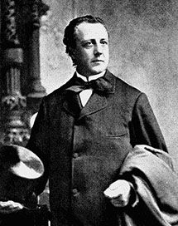
What a friend we have in Jesus
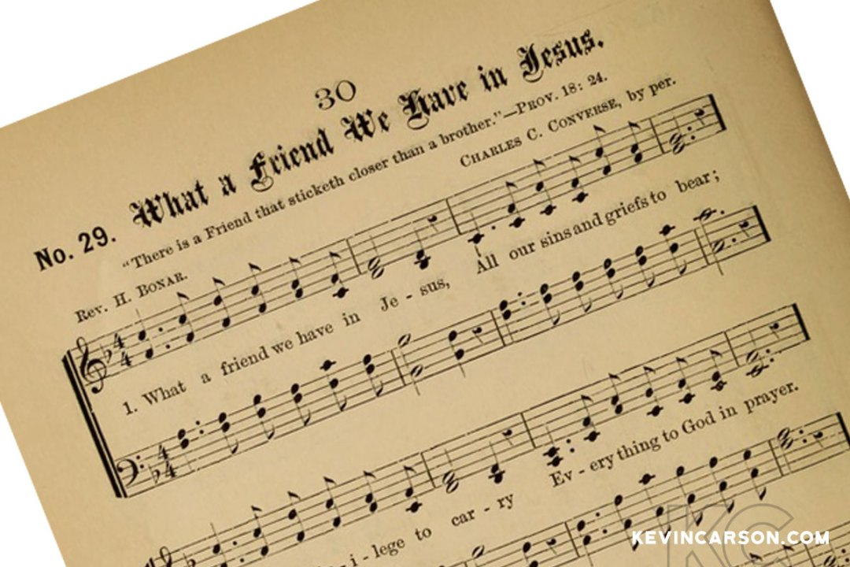
The story behind the hymn.
A true friend loves and accepts us just as we are, stays close to us in good or bad, and is always ready to help in time of need. Because the author of this hymn text found just such a friend in his Lord, he decided to spend his entire life showing real friendship to others.
Joseph Scriven had wealth, education, a devoted family, and a pleasant life in his native Ireland. Then unexpected tragedy entered. On the night before Scriven’s scheduled wedding, his fiancée drowned. In his deep sorrow. Joseph realised that he could find the solace and support he needed only in his dearest friend, Jesus.
Soon after this tragedy, Scriven dramatically changed his lifestyle, He left Ireland for Port Hope, Canada, determined to devote all of his extra time in being a friend and helper to others. He often gave away his clothing and possessions to those in need, and he worked – without pay – for anyone who needed him. Scriven became known as “the Good Samaritan of Port Hope.”
When Scriven’s mother became ill in Ireland, he wrote a comforting letter to her, enclosing the words of his newly written poem with the prayer that these brief lines would remind her of a
never-failing heavenly Friend. Sometime later, when Joseph Scriven, himself was ill, a friend who came to call on him happened to see a copy of these words scribbled on scratch paper near his bed. The friend read the lines with interest and asked, “Who wrote those beautiful words?”
“The Lord and I did it between us,” was Scriven’s reply.







PARKING FOR THE AIRPORT at Forest Methodist
We are letting out five spaces, on a first come, first served basis, at a cost of £25 per week or part thereof. These parking spaces will be at the back of the top rear car park and will be delineated.
THIS WILL BE ENTIRELY AT CAR OWNERS RISK
To reserve a space please email rosemary.willey@gmail.com and cc to carolejehan1972@gmail.com.
You will need to provide your car number, dates required and a contact telephone number. Please can you display your Christian name on your dashboard when leaving the vehicle.
It should be noted that on the rare occasions when the car park is full, I.e. funerals, access to your vehicle may be temporarily delayed.
THERE IS TO BE NO UNAUTHORISED USE OF PARKING SPACES WITHOUT FOLLOWING THE ABOVE GUIDELINES.

Circuit Prayer Day
🙏Les Adams 🙏
Sat 18th April 10-4pm
😀Drop in anytime😀
We have different ways to pray, something for everyone!
📝🎨🤫 🧁☕
For your diary- future dates 18th July tba and 17th Oct tba
Any questions to Revd Jacky



Prayer Pages

IN YOUR PRAYERS
If you know of someone who would appreciate being on our prayer list, please ensure you have the person's permission before passing their name to Michelle.
Please pray for Win De La Mare, Karen Harrison,
Rachel Meinke, Caroline Treharne, Joyce Baudains,
Margaret Boden-Heaume, Bob Cartmell,
Rev John Luff and his wife Carole,
Howard Ellis (Sandra’s son), Debbie Hobbs,
Colleen Ogier, Debbie Dorey,
Sarah’s grandson Edward
And Philip Salmon

Bailiwick of Guernsey Churches Prayer Cycle for 2026
Mar 01 Les Bourgs Hospice & Princess Elizabeth Hospital: patients, staff, chaplaincy (Day of prayer for unemployed people)
Mar 06 WORLD DAY OF PRAYER
Mar 08 Parish Church of St Peter Port (Town Church)
Mar 15 MOTHERING SUNDAY
Mar 22 St John’s church & Wesley Methodist church & Community Centre
Mar 29 PALM SUNDAY

FACTOR 7
Please pray wherever you are: at home, work, in your car or shower, pray for
7 minutes at 7am and/or 7pm
FOCUS THIS MONTH

Please pray for all involved in education - those who learn, those who enable learning, and those who support in many ways. Pray too for the learning of all ages within church communities - for growth in faith and the impact that has on daily life.

As we continue our journey through Lent with the Bible Studies led by Reverend Jacky, let us pray for a fresh experience of faith in our lives and the Church.



Church chuckles
A nun driving her jeep in the Middle East ran out of petrol. The only container she could find was a chamber pot, in which she collected petrol and with great difficulty refilled the jeep. Some Arabs looking on observed, “Sister, we don’t share your religion, but we do admire your faith.”

Notice in the kitchen of a church hall:
“When you have emptied the teapot please stand
upside down in the sink.”
To which had been added: “No hot bottoms on the formica.”

A bishop was astonished to hear little Mary say that a person must be very brave these days to go to church. “Well,” she said, “ I heard my uncle tell my aunt last Sunday that there was a canon in the pulpit, that the choir murdered the anthem and that the organist drowned the choir.”


